Computer

Definition
# Source: AI Source: Provided by: [Data Path: Persons Table -> ID Column: 1, Name_En Column: Motasem Essam] -> From: [ChatGPT] on [4/22/2026]
A computer is an electronic device that accepts data, processes it according to instructions, and produces useful output (information).

Etymology
# Source: Wiki source: Provided by: [Data Path: Persons Table -> ID Column: 1, Name_En Column: Motasem Essam] -> From: [Data Path: Sources Table -> ID Column: 199, Content Title Column: Wiki Source - Computer] -> at: [Document, page: 1, Heading: Etymology, “It was … higher-level functions.”,] on [4/22/2026]
It was not until the mid-20th century that the word acquired its modern definition; according to the Oxford English Dictionary, the first known use of the word computer was in a different sense, in a 1613 book called The Yong Mans Gleanings by the English writer Richard Brathwait: "I haue [sic] read the truest computer of Times, and the best Arithmetician that euer [sic] breathed, and he reduceth thy dayes into a short number." This usage of the term referred to a human computer, a person who carried out calculations or computations. The word continued to have the same meaning until the middle of the 20th century. During the latter part of this period, women were often hired as computers because they could be paid less than their male counterparts.[1] By 1943, most human computers were women.[2]
The Online Etymology Dictionary gives the first attested use of computer in the 1640s, meaning 'one who calculates'; this is an "agent noun from compute (v.)". The Online Etymology Dictionary states that the use of the term to mean "'calculating machine' (of any type) is from 1897." The Online Etymology Dictionary indicates that the "modern use" of the term, to mean 'programmable digital electronic computer' dates from "1945 under this name; [in a] theoretical [sense] from 1937, as Turing machine".[3] The name has remained, although modern computers are capable of many higher-level functions.

🖥️ Simple idea
# Source: AI Source: Provided by: [Data Path: Persons Table -> ID Column: 1, Name_En Column: Motasem Essam] -> From: [ChatGPT] on [4/22/2026]
A computer:
- Takes input (data)
- Processes it (using programs/software)
- Gives output (results or information)
- Stores data if needed

🔄 Basic working cycle
# Source: AI Source: Provided by: [Data Path: Persons Table -> ID Column: 1, Name_En Column: Motasem Essam] -> From: [ChatGPT] on [4/22/2026]
$$\text{Input}→\text{Process}→\text{Output}→\text{Storage}$$

🧠 What makes a computer
# Source: AI Source: Provided by: [Data Path: Persons Table -> ID Column: 1, Name_En Column: Motasem Essam] -> From: [ChatGPT] on [4/22/2026]
A computer is not just one thing—it is a combination of:

🔹 Hardware (physical parts)
# Source: AI Source: Provided by: [Data Path: Persons Table -> ID Column: 1, Name_En Column: Motasem Essam] -> From: [ChatGPT] on [4/22/2026]


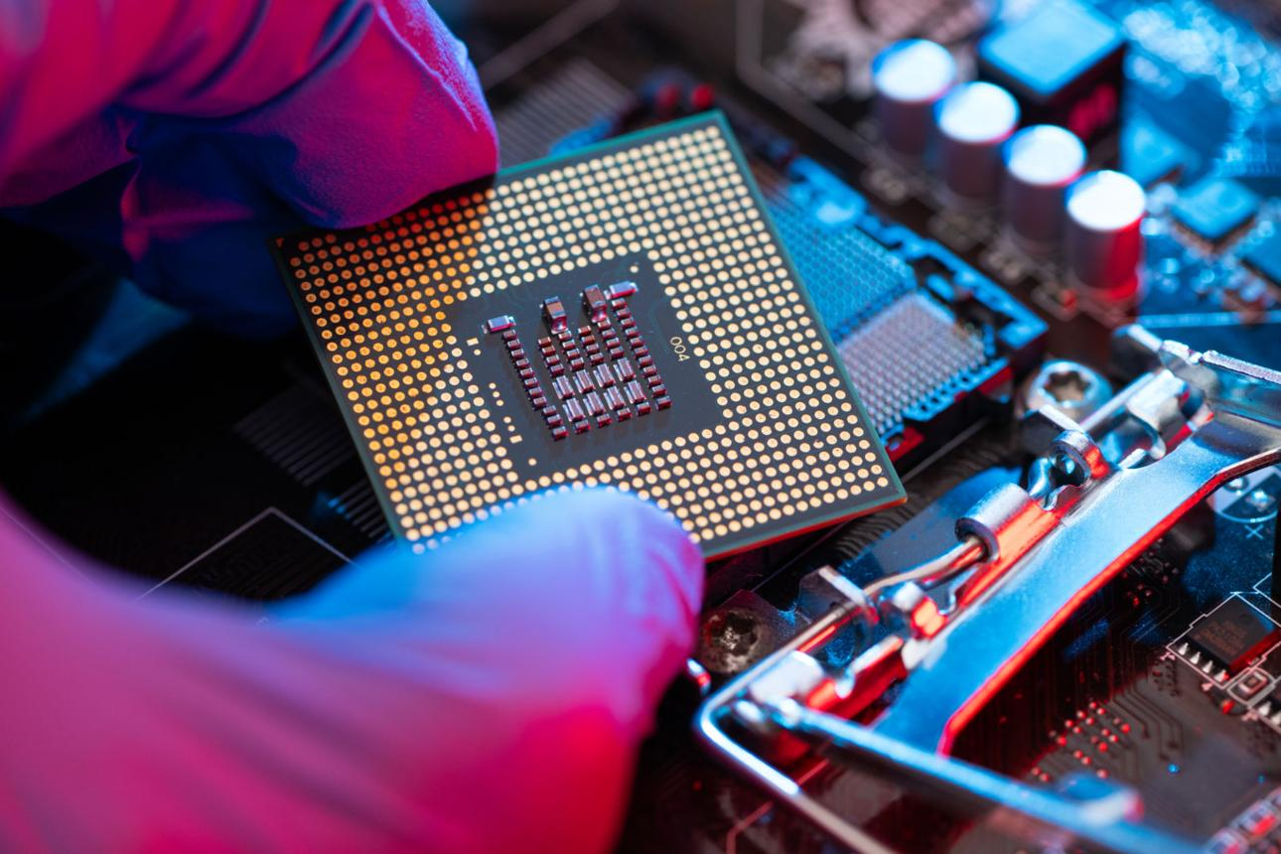
- Keyboard, mouse, screen
- CPU (brain of the computer)
- Memory and storage

🔹 Software (programs)
# Source: AI Source: Provided by: [Data Path: Persons Table -> ID Column: 1, Name_En Column: Motasem Essam] -> From: [ChatGPT] on [4/22/2026]



- Operating systems (Windows, Linux, Android)
- Applications (games, browsers, apps)
- Programs that control hardware

🔹 Interaction Between Software and Hardware
# Source: AI Source: Provided by: [Data Path: Persons Table -> ID Column: 1, Name_En Column: Motasem Essam] -> From: [ChatGPT] on [4/22/2026]
The interaction between software and hardware is what makes a computer actually work. One without the other is useless.

🧠 Core idea
# Source: AI Source: Provided by: [Data Path: Persons Table -> ID Column: 1, Name_En Column: Motasem Essam] -> From: [ChatGPT] on [4/22/2026]
- Hardware = the physical parts (CPU, keyboard, screen)
- Software = the instructions (programs, operating system)
- Interaction = software tells hardware what to do, and hardware carries it out

🔄 How they interact (step by step)
# Source: AI Source: Provided by: [Data Path: Persons Table -> ID Column: 1, Name_En Column: Motasem Essam] -> From: [ChatGPT] on [4/22/2026]
$$\text{User Input}→\text{Software Instructions}→\text{Hardware Processing}→\text{Output}$$

🖥️ Example (typing a letter)
# Source: AI Source: Provided by: [Data Path: Persons Table -> ID Column: 1, Name_En Column: Motasem Essam] -> From: [ChatGPT] on [4/22/2026]
- You press a key on the keyboard (hardware)
- The operating system (software) detects the key press
- The CPU (hardware) processes the signal
- The letter appears on the screen (hardware output)

⚙️ Role of the Operating System
# Source: AI Source: Provided by: [Data Path: Persons Table -> ID Column: 1, Name_En Column: Motasem Essam] -> From: [ChatGPT] on [4/22/2026]
The operating system (OS) is the main software that manages this interaction.
- It acts as a bridge between software and hardware
- It controls devices like keyboard, mouse, printer
- Examples: Windows, Linux, Android

🔧 Real-life analogy
# Source: AI Source: Provided by: [Data Path: Persons Table -> ID Column: 1, Name_En Column: Motasem Essam] -> From: [ChatGPT] on [4/22/2026]
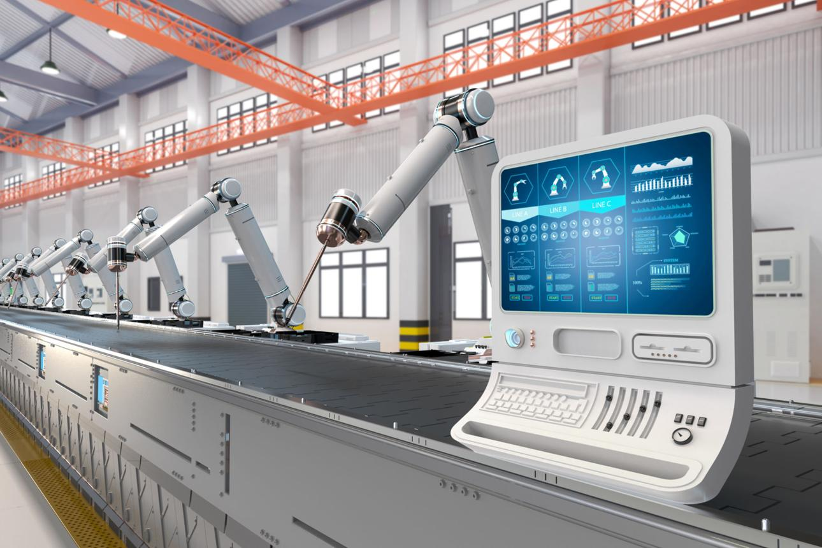

Think of it like:
- Software = driver
- Hardware = car
- Without the driver, the car doesn’t move
- Without the car, the driver can’t go anywhere

🔑 Key points
# Source: AI Source: Provided by: [Data Path: Persons Table -> ID Column: 1, Name_En Column: Motasem Essam] -> From: [ChatGPT] on [4/22/2026]
- Software gives instructions
- Hardware performs actions
- They communicate through the operating system and drivers
- Together, they produce useful results

🧾 One-line summary
# Source: AI Source: Provided by: [Data Path: Persons Table -> ID Column: 1, Name_En Column: Motasem Essam] -> From: [ChatGPT] on [4/22/2026]
The interaction between software and hardware is the process where software controls hardware to perform tasks and produce output.

⚙️ Key idea
# Source: AI Source: Provided by: [Data Path: Persons Table -> ID Column: 1, Name_En Column: Motasem Essam] -> From: [ChatGPT] on [4/22/2026]
- Hardware = physical body
- Software = instructions/mind
- Computer = both working together

Classification of Computers
# Source: AI Source: Provided by: [Data Path: Persons Table -> ID Column: 1, Name_En Column: Motasem Essam] -> From: [ChatGPT] on [4/22/2026]
Computers can be classified in different ways depending on their size, processing power, and functionality. Here’s a clear breakdown:

🖥️ 1. Computers Based on Size
# Source: AI Source: Provided by: [Data Path: Persons Table -> ID Column: 1, Name_En Column: Motasem Essam] -> From: [ChatGPT] on [4/22/2026]
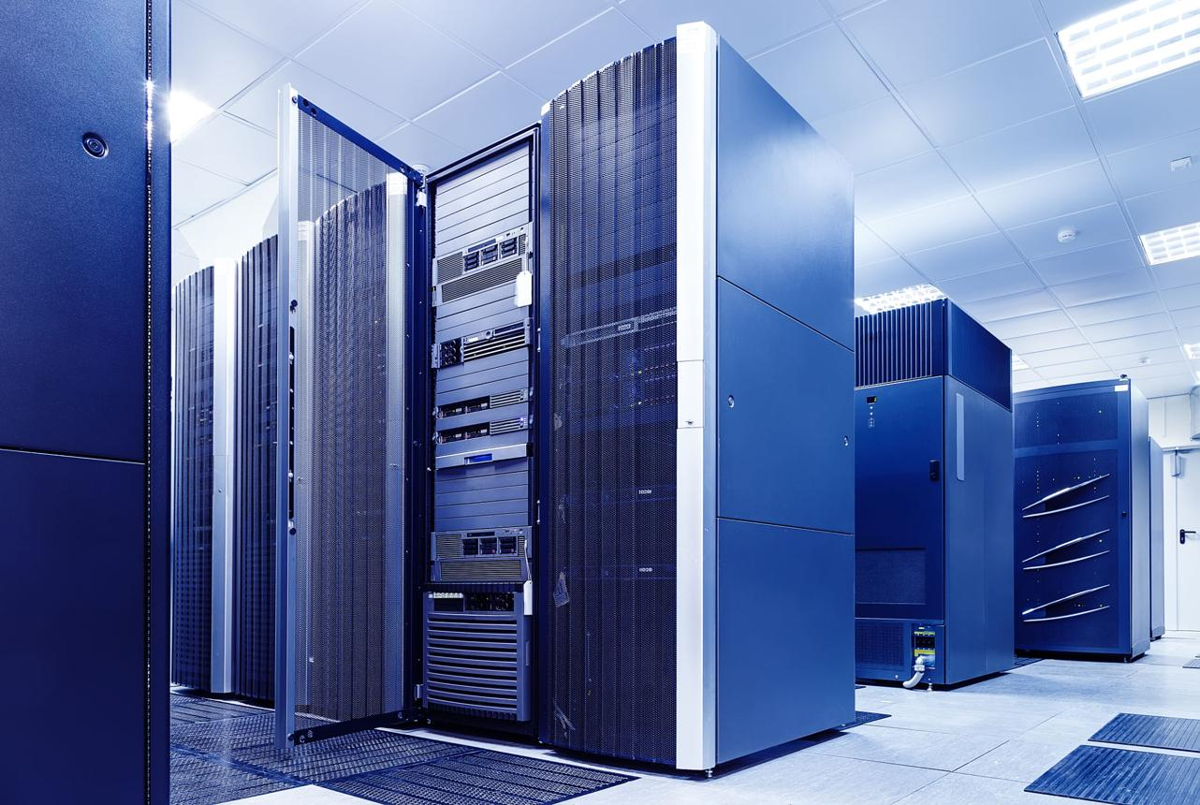
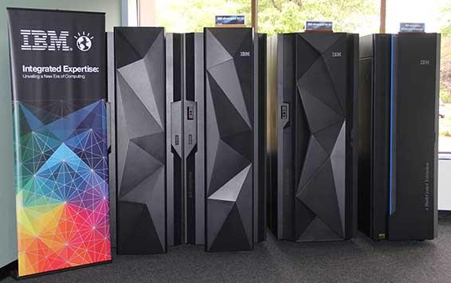
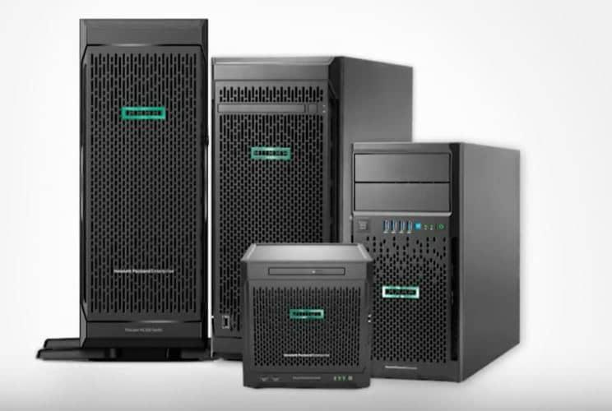
🔹 Supercomputers
- Largest and most powerful machines
- Used for complex tasks like weather forecasting, scientific research
🔹 Mainframe Computers
- Very large systems used by big organizations
- Handle huge amounts of data (banks, airlines)
🔹 Minicomputers
- Medium-sized computers (less common today)
- Used in small to medium businesses
🔹 Microcomputers (Personal Computers)
- Small and affordable
- Examples: desktops, laptops, Mobiles, Wearables, tablets, Workstation, All-in-one PC
# Source: ScreenShots Source: Provided by: [Persons Table -> ID Column: 1, Name_En Column: Motasem Essam] -> Tool: [Lightshot Program] -> From [Site: Google Search: Images: Supercomputers] on [4/22/2026]
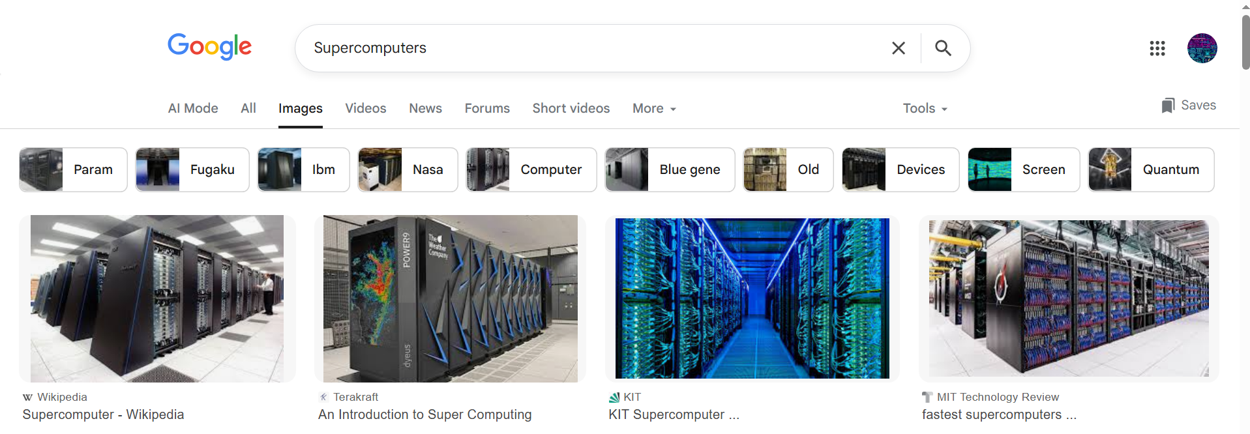

# Source: ScreenShots Source: Provided by: [Persons Table -> ID Column: 1, Name_En Column: Motasem Essam] -> Tool: [Lightshot Program] -> From [Site: Google Search: Images: Mainframe] on [4/22/2026]
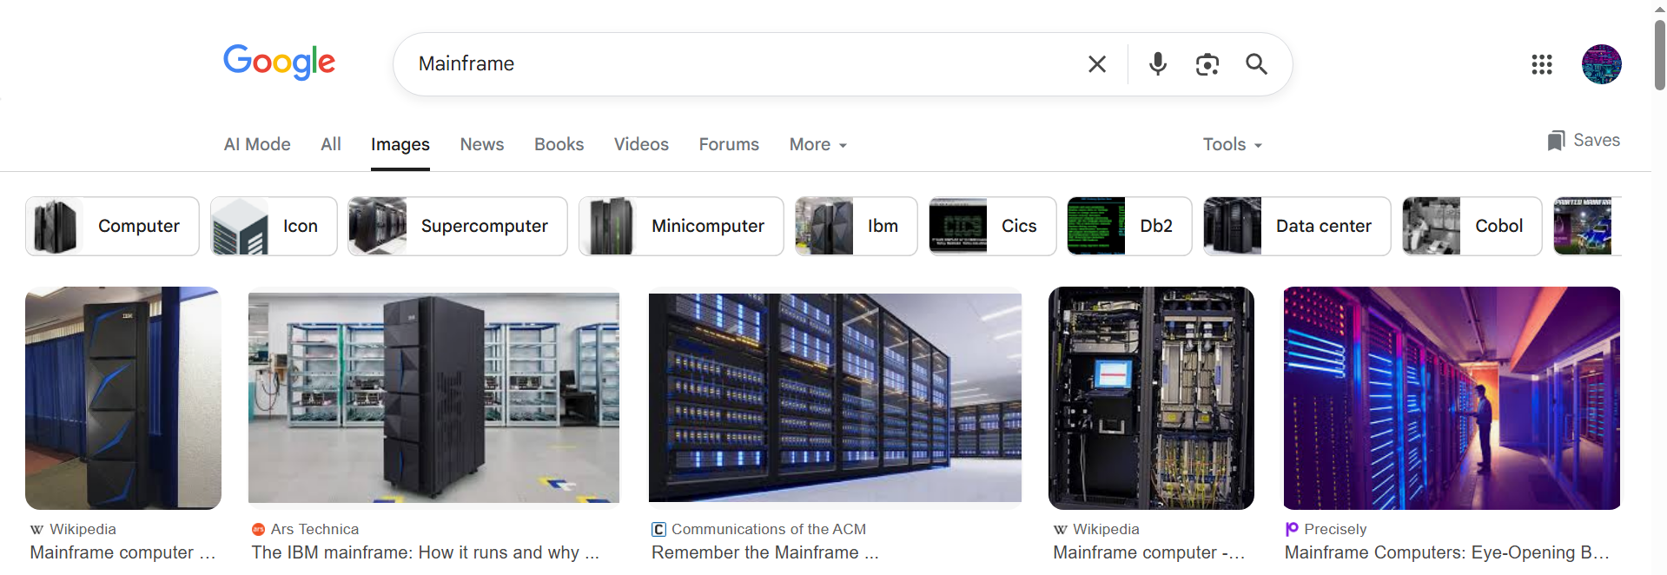
# Source: ScreenShots Source: Provided by: [Persons Table -> ID Column: 1, Name_En Column: Motasem Essam] -> Tool: [Lightshot Program] -> From [Site: Google Search: Images: Minicomputers] on [4/22/2026]
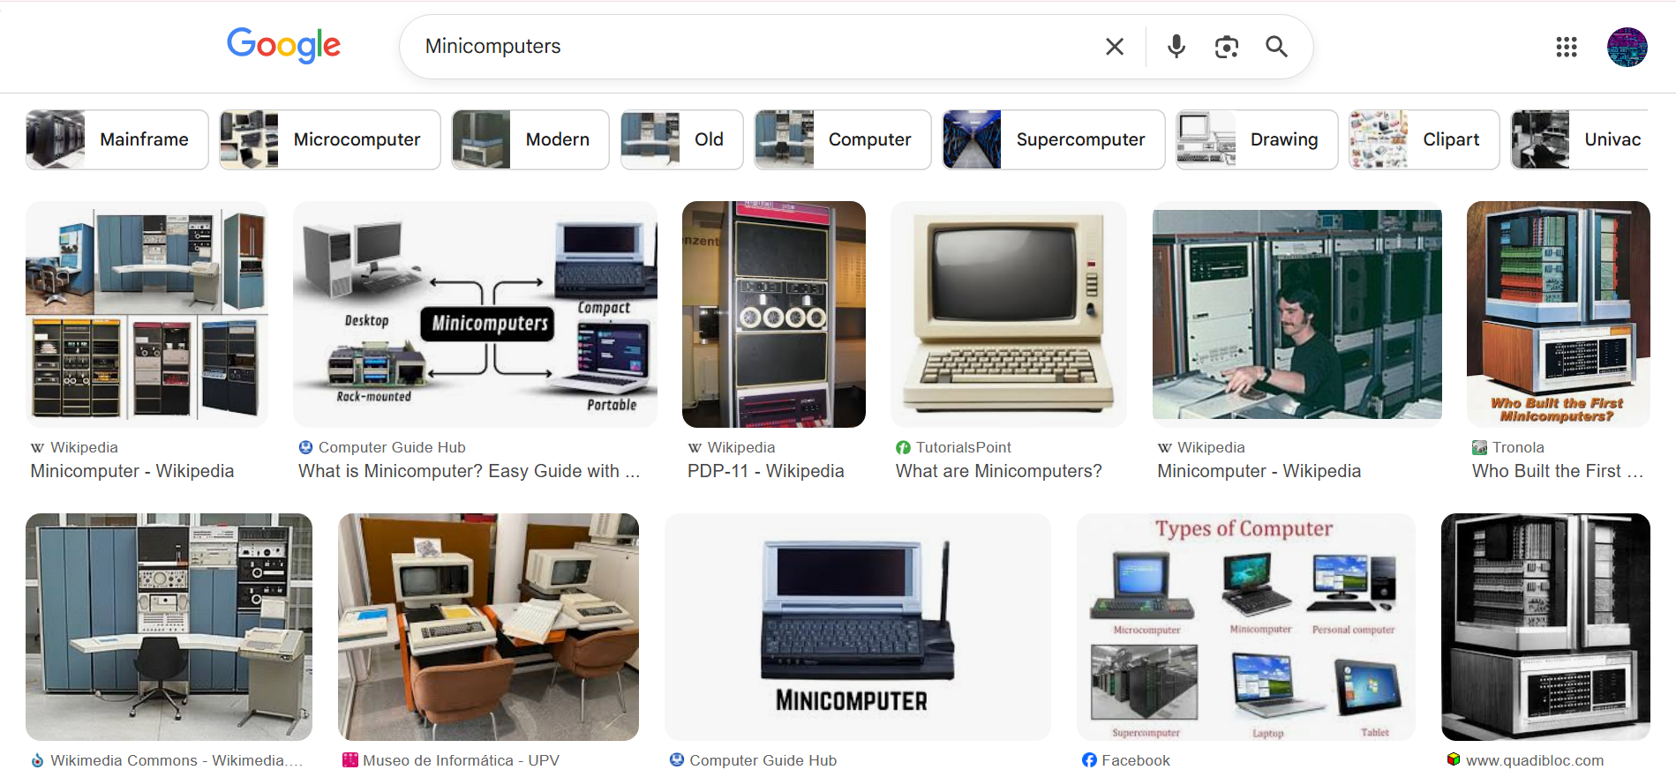

# Source: ScreenShots Source: Provided by: [Persons Table -> ID Column: 1, Name_En Column: Motasem Essam] -> Tool: [Lightshot Program] -> From [Site: Google Search: Images: Microcomputers] on [4/22/2026]
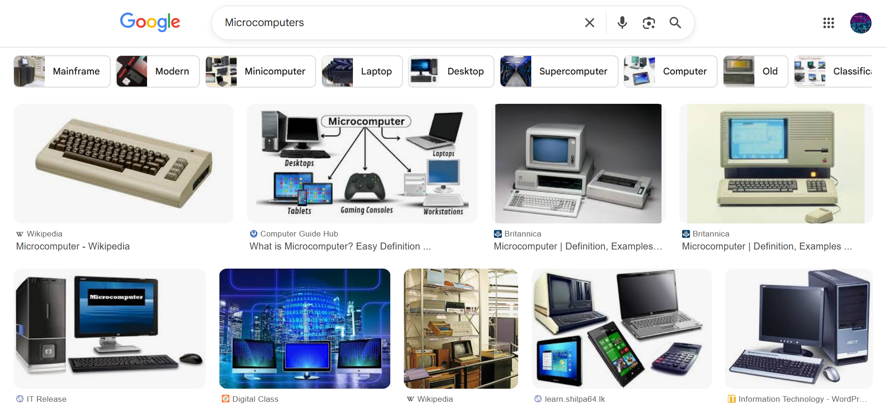

Supercomputer
# Source: Academic source: Provided by: [Data Path: Persons Table -> ID Column: 1, Name_En Column: Motasem Essam] -> From: [Data Path: Sources Table -> ID Column: 158, Content Title Column: Academic Source - Modern academy - 2017-2018 - Intro to Computer Science - Computer systems] -> at: [Document, page: 8, all, “Image - Tool: [Lightshot Program]”] on [4/22/2026]
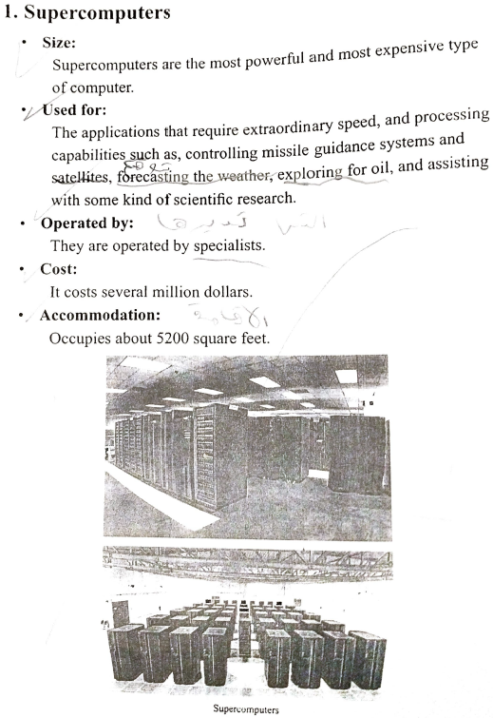

Mainframes
# Source: Academic source: Provided by: [Data Path: Persons Table -> ID Column: 1, Name_En Column: Motasem Essam] -> From: [Data Path: Sources Table -> ID Column: 158, Content Title Column: Academic Source - Modern academy - 2017-2018 - Intro to Computer Science - Computer systems] -> at: [Document, page: 9, all, “Image - Tool: [Lightshot Program]”] on [4/22/2026]
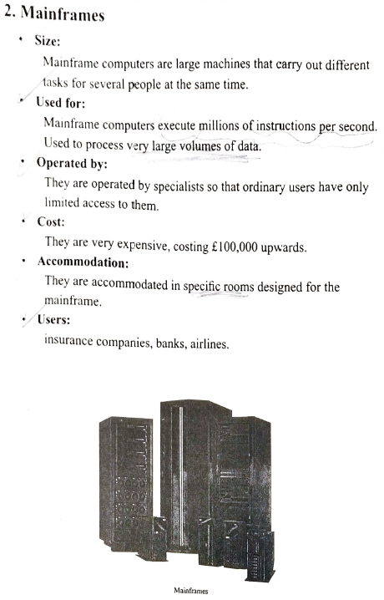

Minicomputers
# Source: Academic source: Provided by: [Data Path: Persons Table -> ID Column: 1, Name_En Column: Motasem Essam] -> From: [Data Path: Sources Table -> ID Column: 158, Content Title Column: Academic Source - Modern academy - 2017-2018 - Intro to Computer Science - Computer systems] -> at: [Document, page: 10, all, “Image - Tool: [Lightshot Program]”] on [4/22/2026]
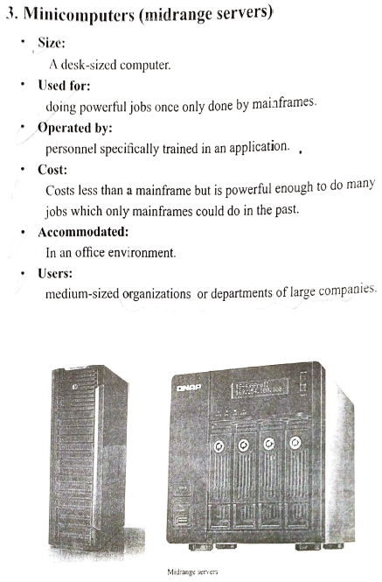

Microcomputer
# Source: Academic source: Provided by: [Data Path: Persons Table -> ID Column: 1, Name_En Column: Motasem Essam] -> From: [Data Path: Sources Table -> ID Column: 158, Content Title Column: Academic Source - Modern academy - 2017-2018 - Intro to Computer Science - Computer systems] -> at: [Document, page: 11, all, “Image - Tool: [Lightshot Program]”] on [4/22/2026]
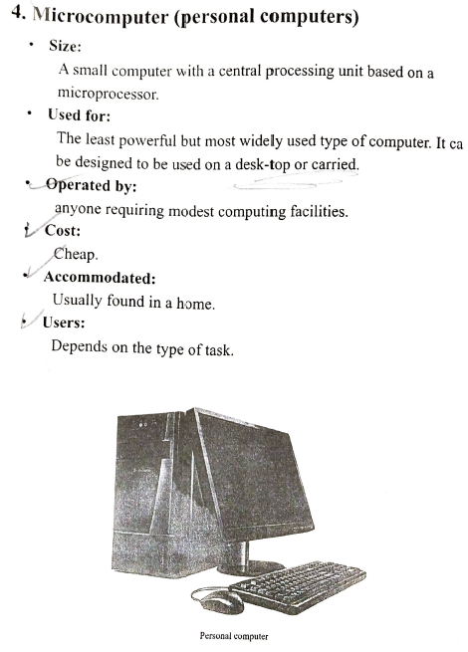

Portable computer
# Source: Academic source: Provided by: [Data Path: Persons Table -> ID Column: 1, Name_En Column: Motasem Essam] -> From: [Data Path: Sources Table -> ID Column: 158, Content Title Column: Academic Source - Modern academy - 2017-2018 - Intro to Computer Science - Computer systems] -> at: [Document, page: 12, all, “Image - Tool: [Lightshot Program]”] on [4/22/2026]
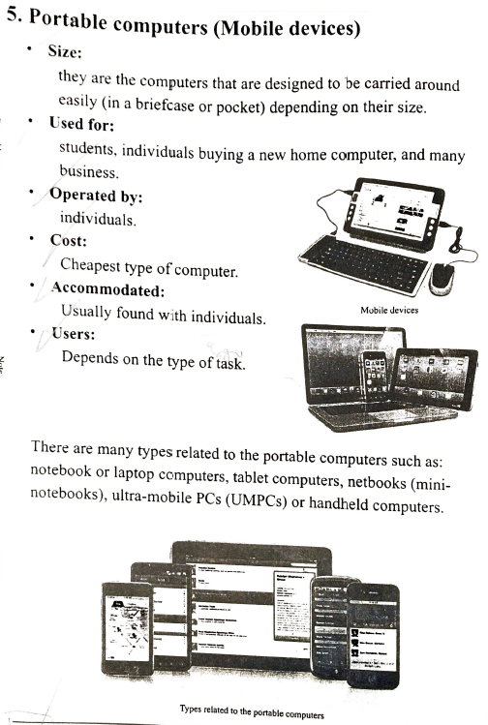

⚡ 2. Computers Based on Processing Power
# Source: AI Source: Provided by: [Data Path: Persons Table -> ID Column: 1, Name_En Column: Motasem Essam] -> From: [ChatGPT] on [4/22/2026]
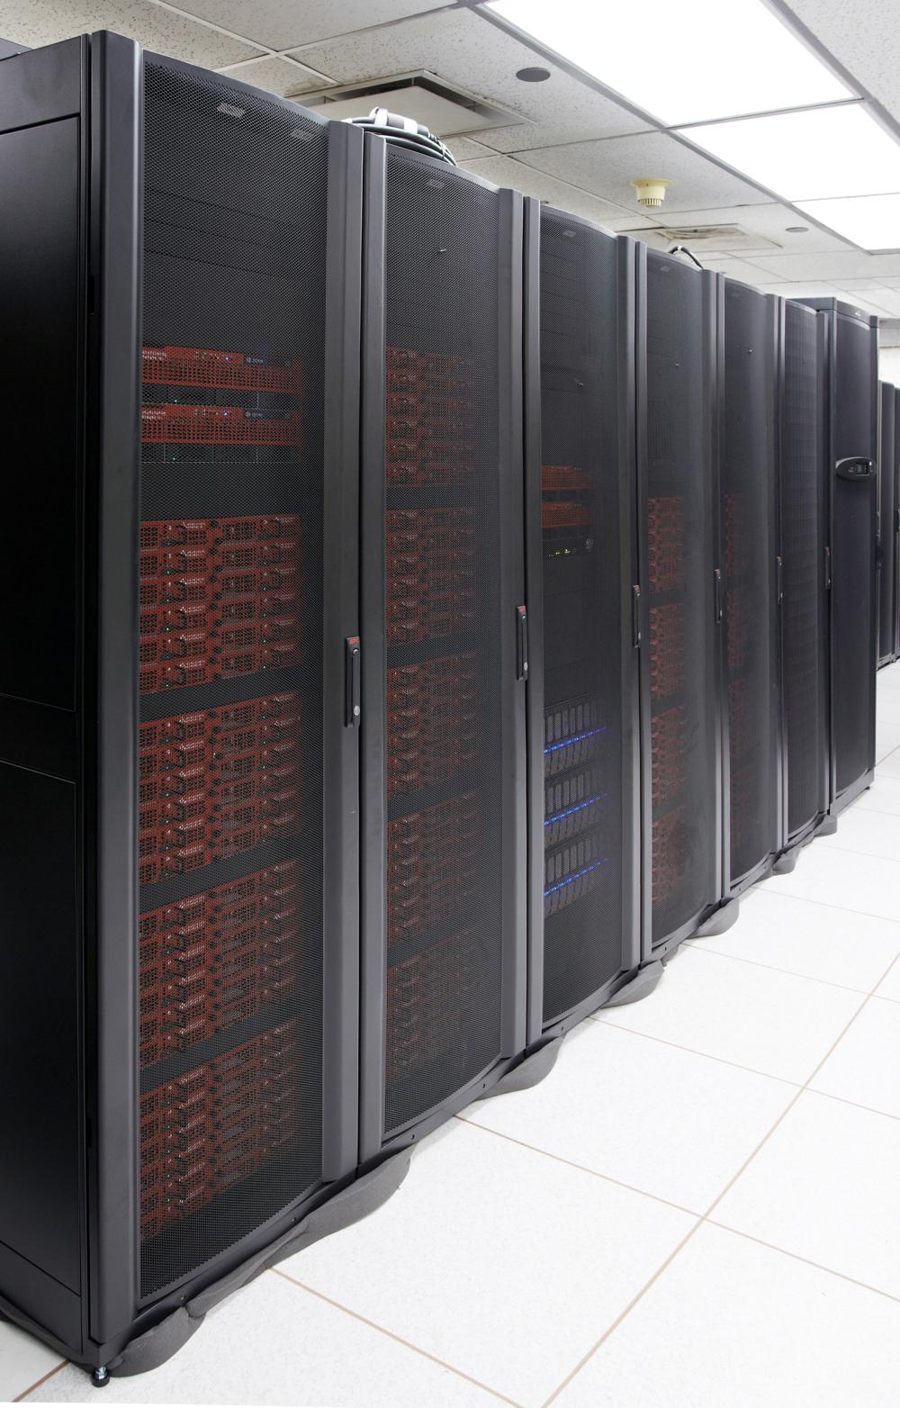
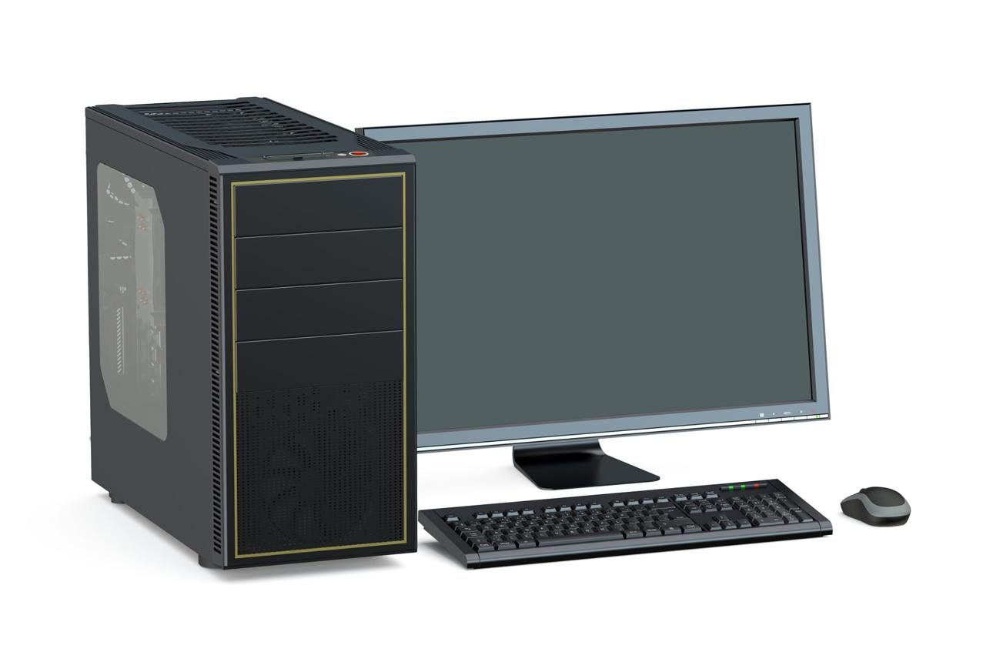
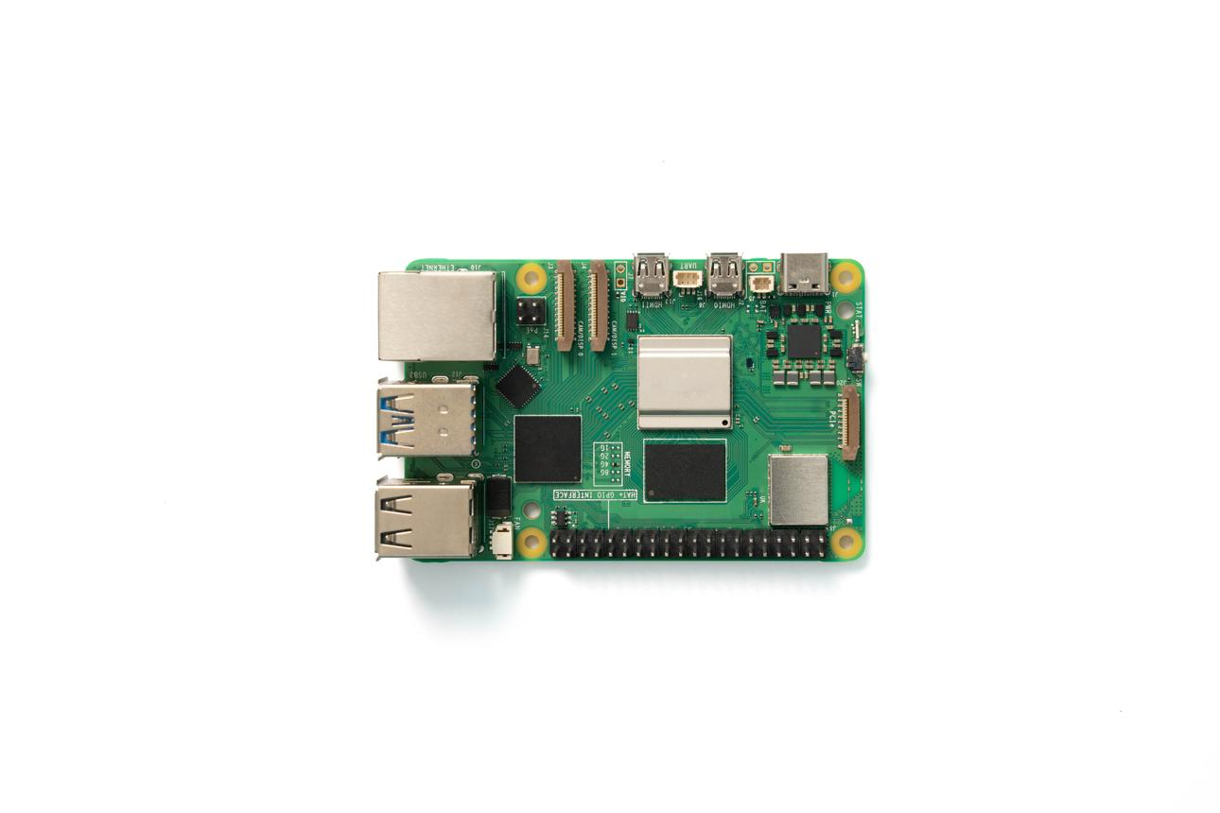
🔹 High-Performance Computers
- Extremely fast and powerful
- Used in research, simulations, AI
🔹 General-Purpose Computers
- Moderate power
- Used for everyday tasks (browsing, office work)
🔹 Low-Power / Embedded Systems
- Limited processing power
- Found in devices like microwaves, cars, smart TVs

Embedded System
# Source: Academic source: Provided by: [Data Path: Persons Table -> ID Column: 1, Name_En Column: Motasem Essam] -> From: [Data Path: Sources Table -> ID Column: 158, Content Title Column: Academic Source - Modern academy - 2017-2018 - Intro to Computer Science - Computer systems] -> at: [Document, page: 13, all, “Image - Tool: [Lightshot Program]”] on [4/22/2026]
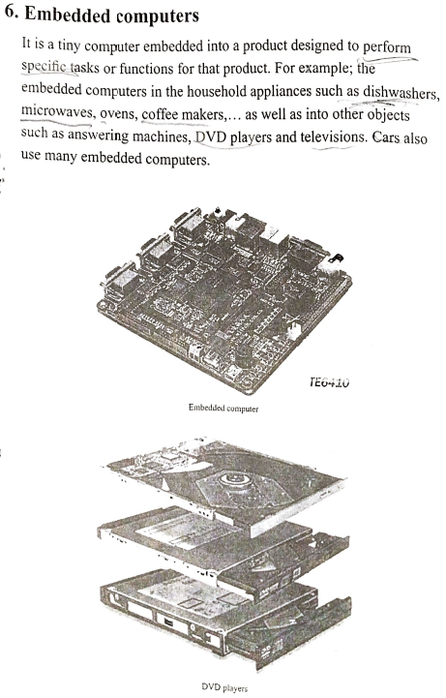

⚙️ 3. Computers Based on Functionality
# Source: AI Source: Provided by: [Data Path: Persons Table -> ID Column: 1, Name_En Column: Motasem Essam] -> From: [ChatGPT] on [4/22/2026]
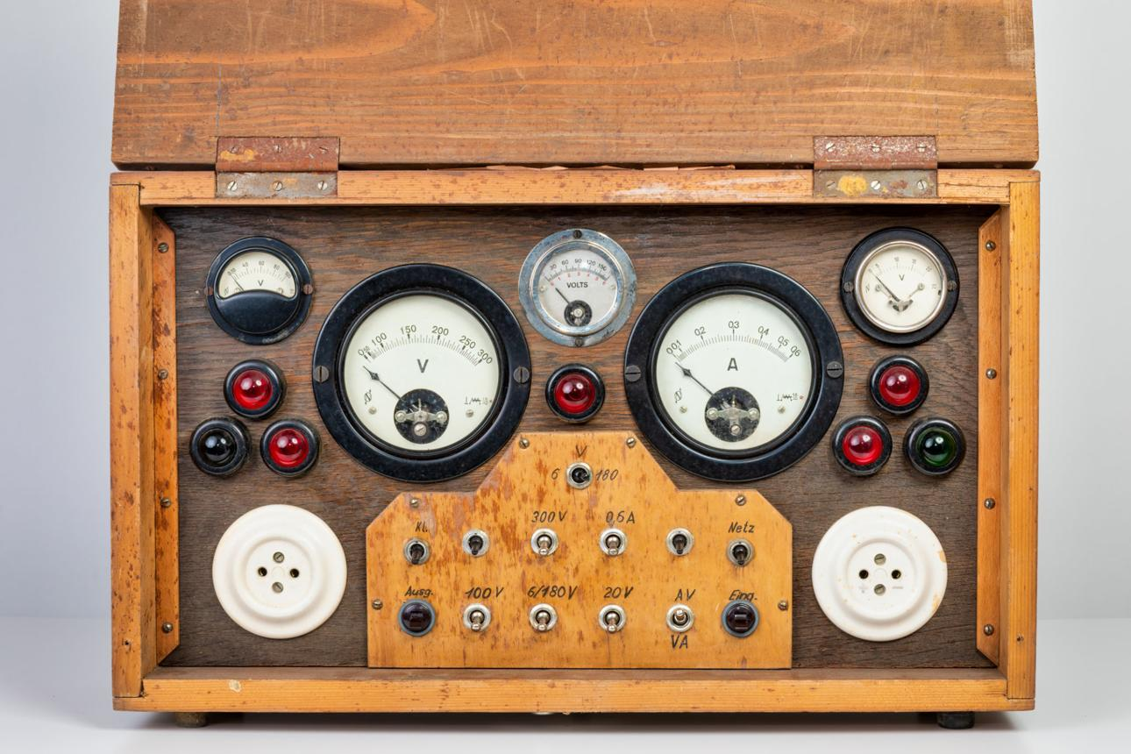

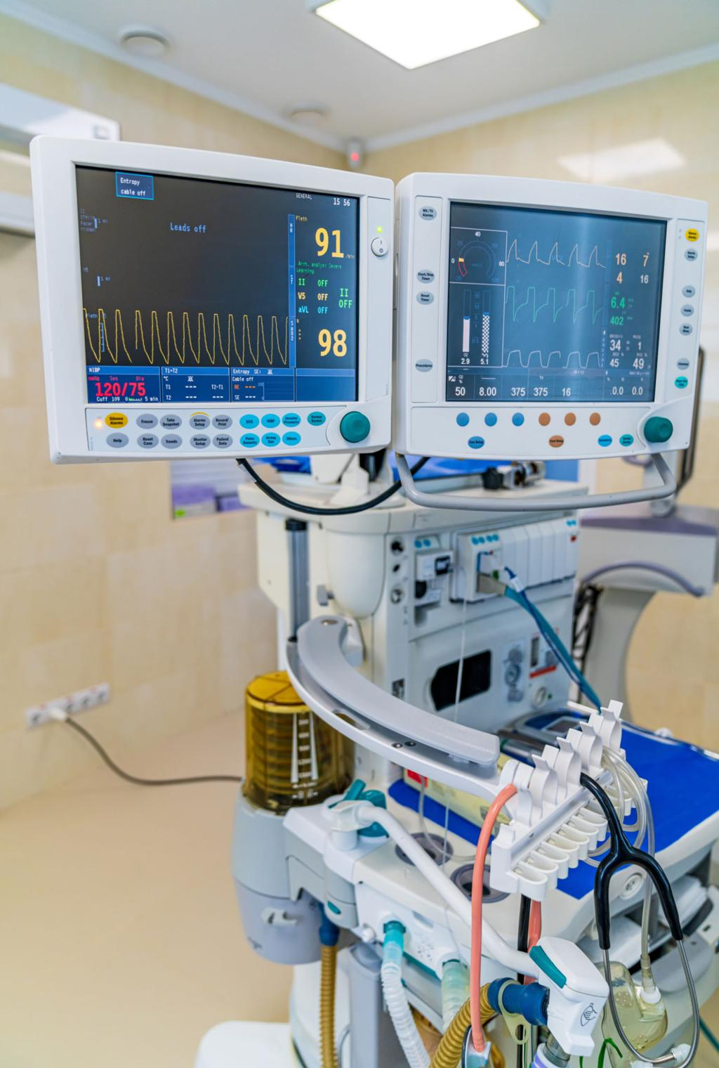
🔹 Analog Computers
- Work with continuous data (e.g., temperature, speed)
- Used in scientific and engineering applications
🔹 Digital Computers
- Work with discrete data (numbers, binary)
- Most modern computers (PCs, smartphones)
🔹 Hybrid Computers
- Combine analog and digital features
- Used in specialized fields like hospitals and research

🧠 Quick summary
- By Size → how big the computer is
- By Processing Power → how fast/strong it is
- By Functionality → how it works with data

💡 4. Classification Based on Technology

1. Electronic computing
# Source: AI Source: Provided by: [Data Path: Persons Table -> ID Column: 1, Name_En Column: Motasem Essam] -> From: [ChatGPT] on [4/22/2026]
Electronic computing is the type of computing in which information is processed and stored using electrical signals (electrons) inside electronic circuits.

🧠 Simple idea
# Source: AI Source: Provided by: [Data Path: Persons Table -> ID Column: 1, Name_En Column: Motasem Essam] -> From: [ChatGPT] on [4/22/2026]
- It uses electricity to represent and process data
- Most modern computers (laptops, phones, desktops) are electronic computers

⚙️ How it works
# Source: AI Source: Provided by: [Data Path: Persons Table -> ID Column: 1, Name_En Column: Motasem Essam] -> From: [ChatGPT] on [4/22/2026]
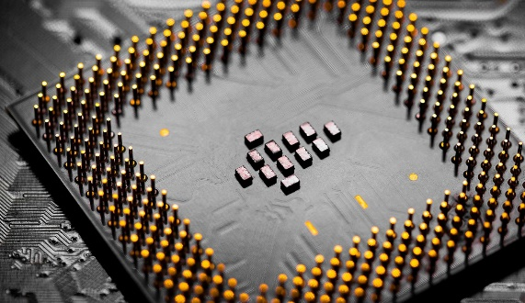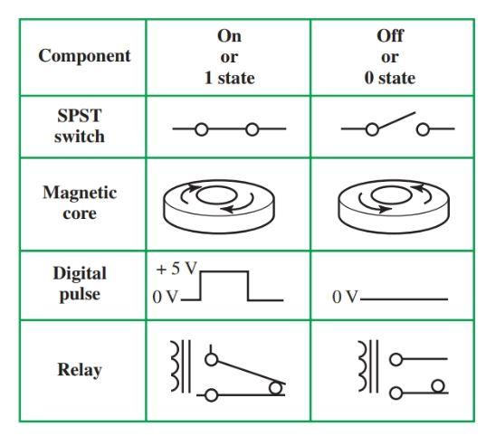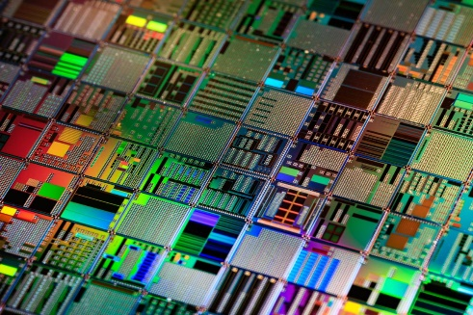
🔹 Basic process:
- Data is converted into electrical signals (0s and 1s)
- Transistors and logic gates process these signals
- CPU performs calculations and decision-making
- Output is displayed or stored

🔌 Key components
# Source: AI Source: Provided by: [Data Path: Persons Table -> ID Column: 1, Name_En Column: Motasem Essam] -> From: [ChatGPT] on [4/22/2026]
- Transistors → tiny switches that control electric flow
- Logic gates → perform basic operations (AND, OR, NOT)
- CPU (processor) → performs all calculations
- Memory (RAM) → temporarily stores data

⚡ Key features of electronic computing
# Source: AI Source: Provided by: [Data Path: Persons Table -> ID Column: 1, Name_En Column: Motasem Essam] -> From: [ChatGPT] on [4/22/2026]
- Very fast processing
- Reliable and accurate
- Can store large amounts of data
- Works using binary system (0 and 1)

💻 Examples
# Source: AI Source: Provided by: [Data Path: Persons Table -> ID Column: 1, Name_En Column: Motasem Essam] -> From: [ChatGPT] on [4/22/2026]
- Desktop computers
- Laptops
- Smartphones
- Tablets
- Servers

⚖️ Simple comparison
# Source: AI Source: Provided by: [Data Path: Persons Table -> ID Column: 1, Name_En Column: Motasem Essam] -> From: [ChatGPT] on [4/22/2026]
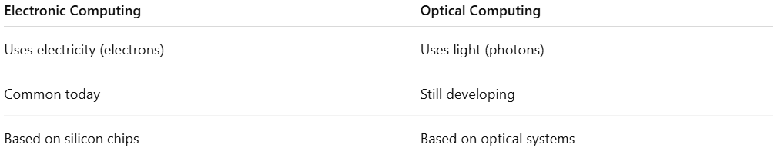
Electronic Computing | Optical Computing
Uses electricity (electrons) | Uses light (photons)
Common today | Still developing
Based on silicon chips | Based on optical systems

🧾 One-line definition
# Source: AI Source: Provided by: [Data Path: Persons Table -> ID Column: 1, Name_En Column: Motasem Essam] -> From: [ChatGPT] on [4/22/2026]
Electronic computing is a method of computing that uses electrical signals to process, store, and transmit data in digital systems.

2. Optical computing
# Source: AI Source: Provided by: [Data Path: Persons Table -> ID Column: 1, Name_En Column: Motasem Essam] -> From: [ChatGPT] on [4/22/2026]
Optical computing is a type of computing that uses light (photons) instead of electricity (electrons) to process and transmit information.

🧠 Simple idea
# Source: AI Source: Provided by: [Data Path: Persons Table -> ID Column: 1, Name_En Column: Motasem Essam] -> From: [ChatGPT] on [4/22/2026]
- Normal computers use electric signals
- Optical computers use light signals (laser or photons)
- Light can move faster and carry more data than electricity

💡 How it works
# Source: AI Source: Provided by: [Data Path: Persons Table -> ID Column: 1, Name_En Column: Motasem Essam] -> From: [ChatGPT] on [4/22/2026]
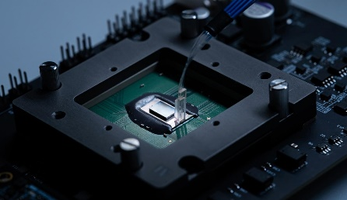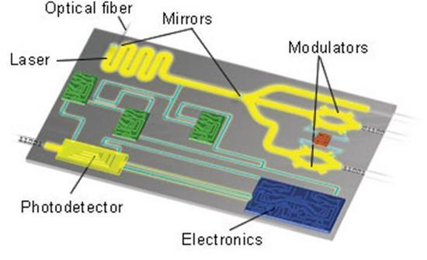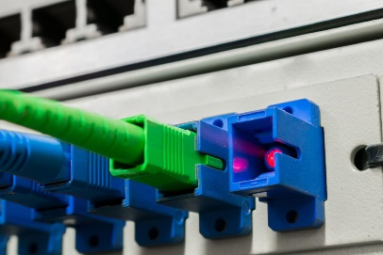
🔹 Basic process:
- Data is converted into light signals
- Light travels through optical components (fibers, lasers, lenses)
- It performs operations like switching or processing
- Output is converted back into electrical signals (if needed)

⚡ Key features
# Source: AI Source: Provided by: [Data Path: Persons Table -> ID Column: 1, Name_En Column: Motasem Essam] -> From: [ChatGPT] on [4/22/2026]
🔹 1. Very fast
- Light travels faster than electrical signals
- Enables high-speed data processing
🔹 2. High bandwidth
- Can carry large amounts of data simultaneously
🔹 3. Less heat
- Produces less heat compared to electronic circuits
🔹 4. Low interference
- Light signals are less affected by electromagnetic noise

🔬 Where it is used (or being researched)
# Source: AI Source: Provided by: [Data Path: Persons Table -> ID Column: 1, Name_En Column: Motasem Essam] -> From: [ChatGPT] on [4/22/2026]
- High-speed internet (fiber optics)
- Supercomputing research
- Advanced AI and data centers
- Optical communication systems

⚖️ Optical vs Electronic computing
# Source: AI Source: Provided by: [Data Path: Persons Table -> ID Column: 1, Name_En Column: Motasem Essam] -> From: [ChatGPT] on [4/22/2026]
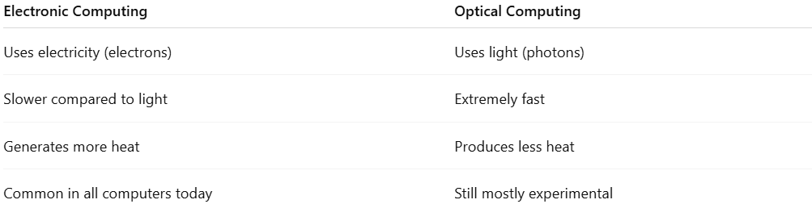
Electronic Computing | Optical Computing
Uses electricity (electrons) | Uses light (photons)
Slower compared to light | Extremely fast
Generates more heat | Produces less heat
Common in all computers today | Still mostly experimental

🧾 One-line definition
# Source: AI Source: Provided by: [Data Path: Persons Table -> ID Column: 1, Name_En Column: Motasem Essam] -> From: [ChatGPT] on [4/22/2026]
Optical computing is a computing technology that uses light instead of electricity to process and transmit information.

3. Quantum computing
# Source: AI Source: Provided by: [Data Path: Persons Table -> ID Column: 1, Name_En Column: Motasem Essam] -> From: [ChatGPT] on [4/22/2026]
Quantum computing is a type of computing that uses the principles of Quantum Mechanics to process information in a fundamentally different way from classical computers.

🧠 Simple idea
# Source: AI Source: Provided by: [Data Path: Persons Table -> ID Column: 1, Name_En Column: Motasem Essam] -> From: [ChatGPT] on [4/22/2026]
- Traditional computers use bits (0 or 1)
- Quantum computers use qubits, which can be 0, 1, or both at the same time

🔬 Key concepts in quantum computing
# Source: AI Source: Provided by: [Data Path: Persons Table -> ID Column: 1, Name_En Column: Motasem Essam] -> From: [ChatGPT] on [4/22/2026]
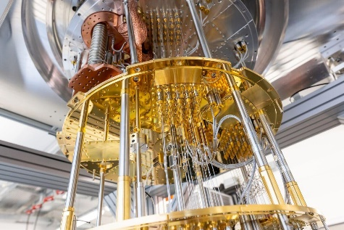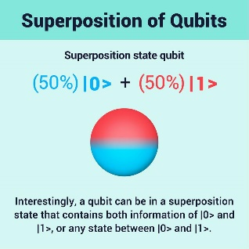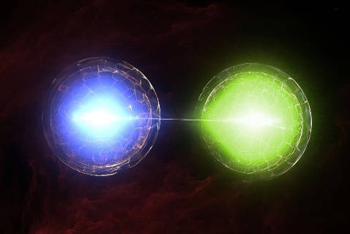
🔹 Superposition
A qubit can exist in multiple states at once, allowing many calculations simultaneously.
🔹 Entanglement
Qubits can be linked together, so the state of one instantly affects another.
🔹 Quantum Parallelism
Quantum computers can explore many possibilities at the same time, making them powerful for certain problems.

⚡ Why it’s important
# Source: AI Source: Provided by: [Data Path: Persons Table -> ID Column: 1, Name_En Column: Motasem Essam] -> From: [ChatGPT] on [4/22/2026]
Quantum computers can solve some problems much faster than classical computers, such as:
- Cryptography (breaking or creating secure codes)
- Drug discovery and chemistry simulations
- Optimization problems (logistics, traffic, AI)

🖥️ Classical vs Quantum
# Source: AI Source: Provided by: [Data Path: Persons Table -> ID Column: 1, Name_En Column: Motasem Essam] -> From: [ChatGPT] on [4/22/2026]
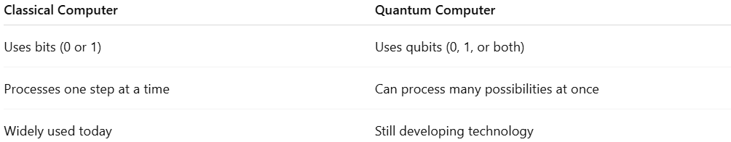
Classical Computer | Quantum Computer
Uses bits (0 or 1) | Uses qubits (0, 1, or both)
Processes one step at a time | Can process many possibilities at once
Widely used today | Still developing technology

🧾 One-line definition
# Source: AI Source: Provided by: [Data Path: Persons Table -> ID Column: 1, Name_En Column: Motasem Essam] -> From: [ChatGPT] on [4/22/2026]
Quantum computing is a new type of computing that uses quantum physics to perform complex calculations much faster than traditional computers.

4. Biological Computing (Bio-computing)
# Source: AI Source: Provided by: [Data Path: Persons Table -> ID Column: 1, Name_En Column: Motasem Essam] -> From: [ChatGPT] on [4/22/2026]
Biological computing is a type of computing that uses biological materials and processes (like DNA, cells, or proteins) to perform computation instead of traditional silicon-based electronics.

🧠 Simple idea
# Source: AI Source: Provided by: [Data Path: Persons Table -> ID Column: 1, Name_En Column: Motasem Essam] -> From: [ChatGPT] on [4/22/2026]
Instead of using electric circuits and transistors, bio-computing uses living systems or biological molecules to store and process information.

🔬 How it works
# Source: AI Source: Provided by: [Data Path: Persons Table -> ID Column: 1, Name_En Column: Motasem Essam] -> From: [ChatGPT] on [4/22/2026]
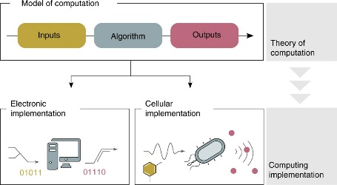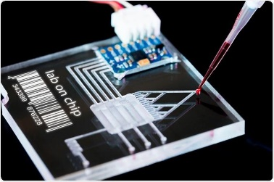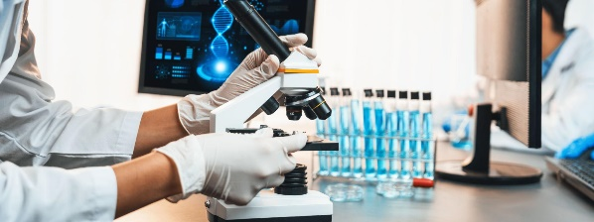
- Information is encoded in DNA sequences (A, T, C, G)
- Biological reactions are used to perform calculations
- Results are obtained through chemical or genetic analysis

🧪 Example
# Source: AI Source: Provided by: [Data Path: Persons Table -> ID Column: 1, Name_En Column: Motasem Essam] -> From: [ChatGPT] on [4/22/2026]
A famous example is DNA computing:
- DNA strands are used to represent data
- Chemical reactions perform operations
- Used to solve very complex problems (like searching huge combinations)

⚙️ Key features
# Source: AI Source: Provided by: [Data Path: Persons Table -> ID Column: 1, Name_En Column: Motasem Essam] -> From: [ChatGPT] on [4/22/2026]
- 🧬 Uses biological molecules (DNA, proteins, cells)
- ⚡ Extremely parallel processing (many reactions at once)
- 🔋 Very energy efficient
- 🔬 Still mostly in research stage

🌍 Applications
# Source: AI Source: Provided by: [Data Path: Persons Table -> ID Column: 1, Name_En Column: Motasem Essam] -> From: [ChatGPT] on [4/22/2026]
- Medical diagnostics
- Drug discovery
- Genetic research
- Solving complex optimization problems

🧾 One-line definition
# Source: AI Source: Provided by: [Data Path: Persons Table -> ID Column: 1, Name_En Column: Motasem Essam] -> From: [ChatGPT] on [4/22/2026]
Biological computing is a form of computing that uses biological systems, such as DNA and cells, to process information instead of electronic circuits.

🔄 Relation to other computing types
# Source: AI Source: Provided by: [Data Path: Persons Table -> ID Column: 1, Name_En Column: Motasem Essam] -> From: [ChatGPT] on [4/22/2026]
- Electronic computing → electricity
- Optical computing → light
- Quantum computing → quantum physics
- Biological computing → living systems (DNA/cells)

5. Neuromorphic Computing
# Source: AI Source: Provided by: [Data Path: Persons Table -> ID Column: 1, Name_En Column: Motasem Essam] -> From: [ChatGPT] on [4/22/2026]
Neuromorphic computing is a type of computing that is designed to mimic the structure and working of the human brain using artificial neurons and synapses.

🧠 Simple idea
# Source: AI Source: Provided by: [Data Path: Persons Table -> ID Column: 1, Name_En Column: Motasem Essam] -> From: [ChatGPT] on [4/22/2026]
Instead of following traditional step-by-step processing like normal computers, neuromorphic systems try to think and process information more like a brain does.

🧬 How it works
# Source: AI Source: Provided by: [Data Path: Persons Table -> ID Column: 1, Name_En Column: Motasem Essam] -> From: [ChatGPT] on [4/22/2026]
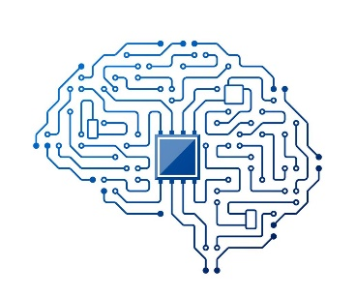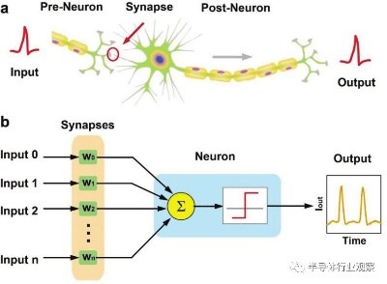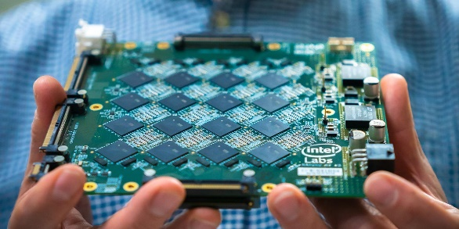
- Uses artificial neurons (like brain cells)
- Uses synapses (connections between neurons)
- Processes information using spikes (signals), not continuous calculations
- Works in a parallel and event-driven way (like the brain)

⚙️ Key features
# Source: AI Source: Provided by: [Data Path: Persons Table -> ID Column: 1, Name_En Column: Motasem Essam] -> From: [ChatGPT] on [4/22/2026]
- 🧠 Brain-inspired design
- ⚡ Very energy efficient
- 🔄 Processes many signals at once (parallel processing)
- 🤖 Good for AI tasks like recognition and learning

🌍 Applications
# Source: AI Source: Provided by: [Data Path: Persons Table -> ID Column: 1, Name_En Column: Motasem Essam] -> From: [ChatGPT] on [4/22/2026]
- Artificial Intelligence (AI)
- Robotics
- Image and speech recognition
- Smart sensors and autonomous systems

🧾 One-line definition
# Source: AI Source: Provided by: [Data Path: Persons Table -> ID Column: 1, Name_En Column: Motasem Essam] -> From: [ChatGPT] on [4/22/2026]
Neuromorphic computing is a brain-inspired computing system that uses artificial neurons and synapses to process information like the human nervous system.

🔄 Quick comparison
# Source: AI Source: Provided by: [Data Path: Persons Table -> ID Column: 1, Name_En Column: Motasem Essam] -> From: [ChatGPT] on [4/22/2026]
- Traditional computers → follow step-by-step instructions
- Neuromorphic computers → process information like a brain (fast, parallel, adaptive)

🌐 5. Special classifications (by role)
# Source: AI Source: Provided by: [Data Path: Persons Table -> ID Column: 1, Name_En Column: Motasem Essam] -> From: [ChatGPT] on [4/22/2026]
This is where servers are best understood:
A server is a computer that provides services, data, or resources to other computers (clients) over a network.
Servers are classified by what they do, such as:
- Web server → hosts websites
- File server → stores and shares files
- Database server → manages databases
- Email server → handles email communication

Computer Users and Professionals
# Source: AI Source: Provided by: [Data Path: Persons Table -> ID Column: 1, Name_En Column: Motasem Essam] -> From: [ChatGPT] on [4/22/2026]
Computer Users and Professionals refers to the different types of people who use computers and those who design, build, manage, and maintain computer systems.

👤 1. Computer Users
# Source: AI Source: Provided by: [Data Path: Persons Table -> ID Column: 1, Name_En Column: Motasem Essam] -> From: [ChatGPT] on [4/22/2026]
These are people who use computers for everyday tasks without necessarily knowing how they work internally.



🔹 Types of users
- Home users → browsing, entertainment, social media
- Students → studying, research, assignments
- Office workers → documents, emails, data entry
- Business users → managing operations, communication
🔑 Key idea:
They focus on using applications, not building them.

👨‍💻 2. Computer Professionals
# Source: AI Source: Provided by: [Data Path: Persons Table -> ID Column: 1, Name_En Column: Motasem Essam] -> From: [ChatGPT] on [4/22/2026]
These are people who create, manage, and improve computer systems and software.

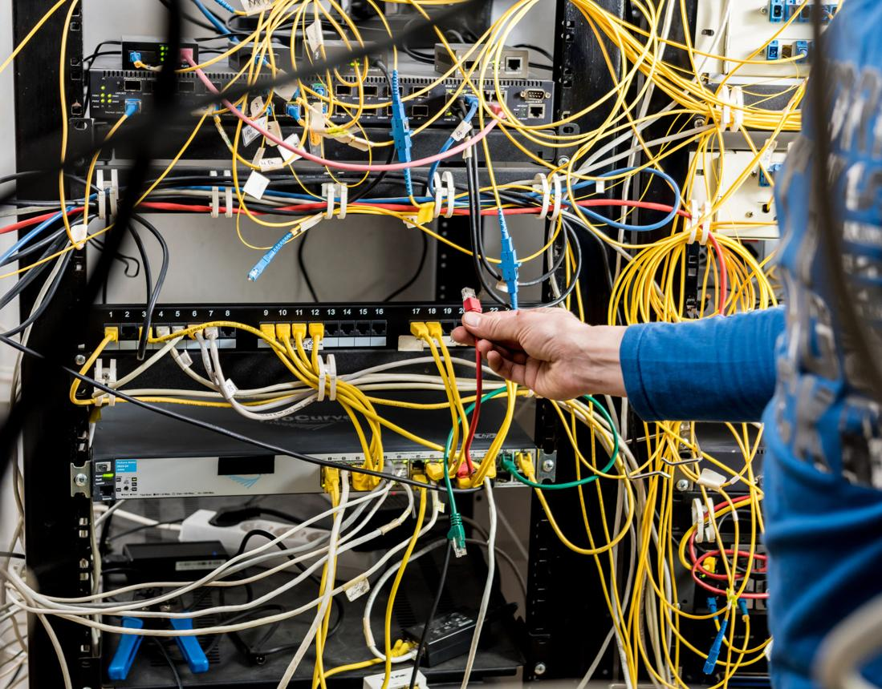
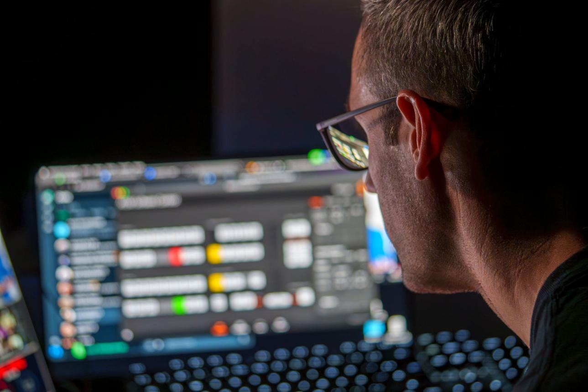
🔹 Types of professionals
- Programmers / Software Developers → write code and build programs
- System Analysts → design and plan computer systems
- Network Engineers → manage networks and servers
- Database Administrators → manage data and databases
- IT Support Technicians → fix hardware/software problems
- Cybersecurity Specialists → protect systems from threats
🔑 Key idea:
They focus on creating, maintaining, and securing systems.

🔄 Main difference
# Source: AI Source: Provided by: [Data Path: Persons Table -> ID Column: 1, Name_En Column: Motasem Essam] -> From: [ChatGPT] on [4/22/2026]
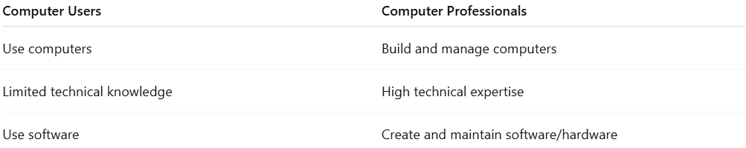
Computer Users | Computer Professionals
Use computers | Build and manage computers
Limited technical knowledge | High technical expertise
Use software | Create and maintain software/hardware

🧠 One-line summary
# Source: AI Source: Provided by: [Data Path: Persons Table -> ID Column: 1, Name_En Column: Motasem Essam] -> From: [ChatGPT] on [4/22/2026]
- Users use computers to perform tasks
- Professionals develop and maintain the systems users depend on

Application of Computer
# Source: AI Source: Provided by: [Data Path: Persons Table -> ID Column: 1, Name_En Column: Motasem Essam] -> From: [ChatGPT] on [4/22/2026]
Applications of computers are the different areas where computers are used to perform tasks, solve problems, and make life easier.

🏫 1. Education
# Source: AI Source: Provided by: [Data Path: Persons Table -> ID Column: 1, Name_En Column: Motasem Essam] -> From: [ChatGPT] on [4/22/2026]


- Online learning and virtual classes
- Research and assignments
- Educational software and simulations

🏥 2. Healthcare
# Source: AI Source: Provided by: [Data Path: Persons Table -> ID Column: 1, Name_En Column: Motasem Essam] -> From: [ChatGPT] on [4/22/2026]
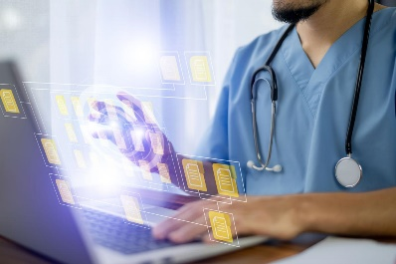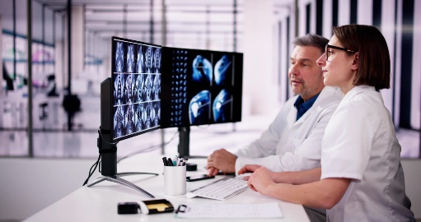
- Storing patient records
- Medical imaging (X-ray, MRI)
- Online consultations (telemedicine)

💼 3. Business
# Source: AI Source: Provided by: [Data Path: Persons Table -> ID Column: 1, Name_En Column: Motasem Essam] -> From: [ChatGPT] on [4/22/2026]

- Accounting and payroll
- Online shopping (e-commerce)
- Data management and communication

🏦 4. Banking and Finance
# Source: AI Source: Provided by: [Data Path: Persons Table -> ID Column: 1, Name_En Column: Motasem Essam] -> From: [ChatGPT] on [4/22/2026]
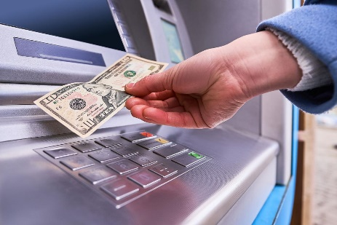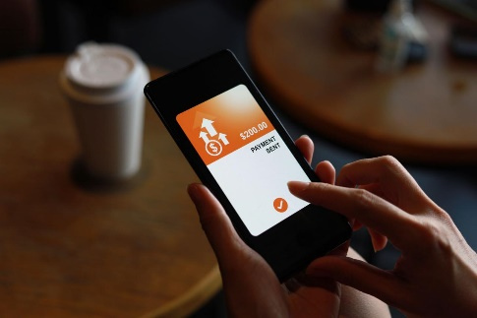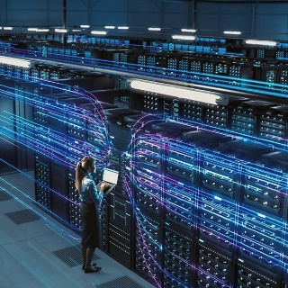
- Online banking and transactions
- ATMs
- Managing financial records

🎮 5. Entertainment
# Source: AI Source: Provided by: [Data Path: Persons Table -> ID Column: 1, Name_En Column: Motasem Essam] -> From: [ChatGPT] on [4/22/2026]
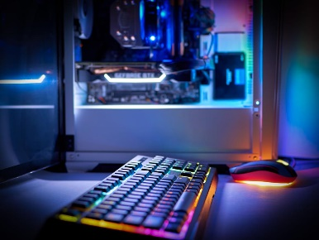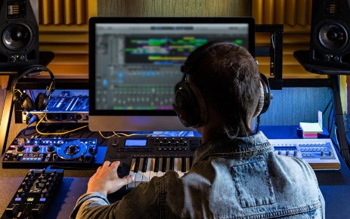
- Video games
- Watching movies and streaming
- Music production

🚀 6. Science and Engineering
# Source: AI Source: Provided by: [Data Path: Persons Table -> ID Column: 1, Name_En Column: Motasem Essam] -> From: [ChatGPT] on [4/22/2026]
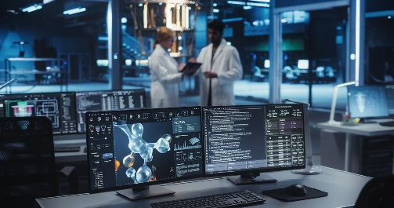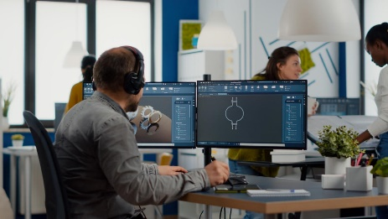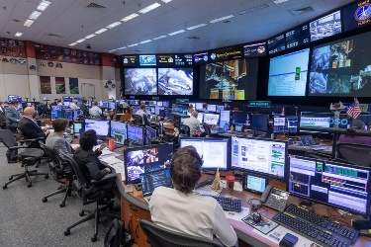
- Scientific research and simulations
- Designing (CAD software)
- Space exploration and weather forecasting

🚗 7. Transportation
# Source: AI Source: Provided by: [Data Path: Persons Table -> ID Column: 1, Name_En Column: Motasem Essam] -> From: [ChatGPT] on [4/22/2026]
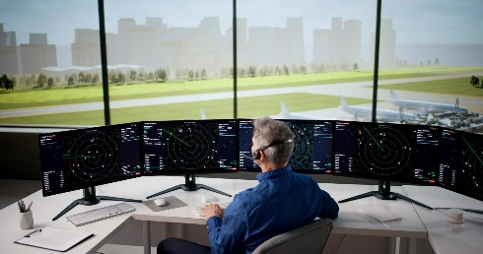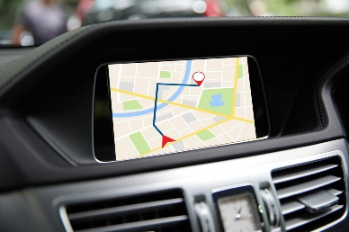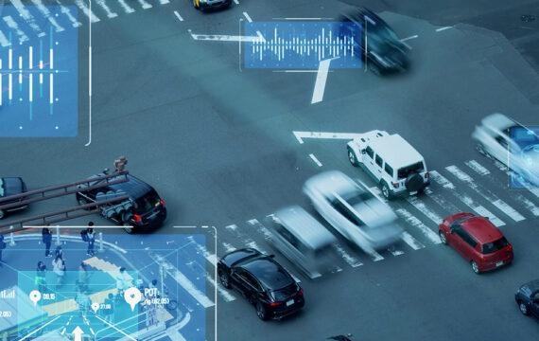
- Traffic control systems
- GPS navigation
- Ticket reservation systems

🧠 One-line summary
# Source: AI Source: Provided by: [Data Path: Persons Table -> ID Column: 1, Name_En Column: Motasem Essam] -> From: [ChatGPT] on [4/22/2026]
Computers are used in almost every field to store, process, and manage information efficiently.

Advantages and Disadvantages of computers
Here’s a clear and balanced view of the advantages and disadvantages of computers:

✅ Advantages of Computers
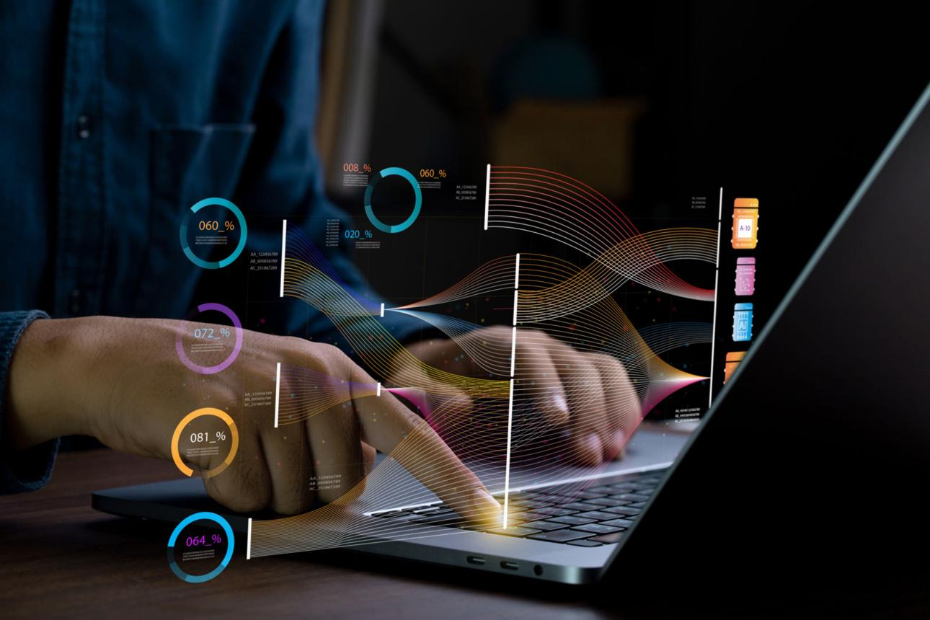

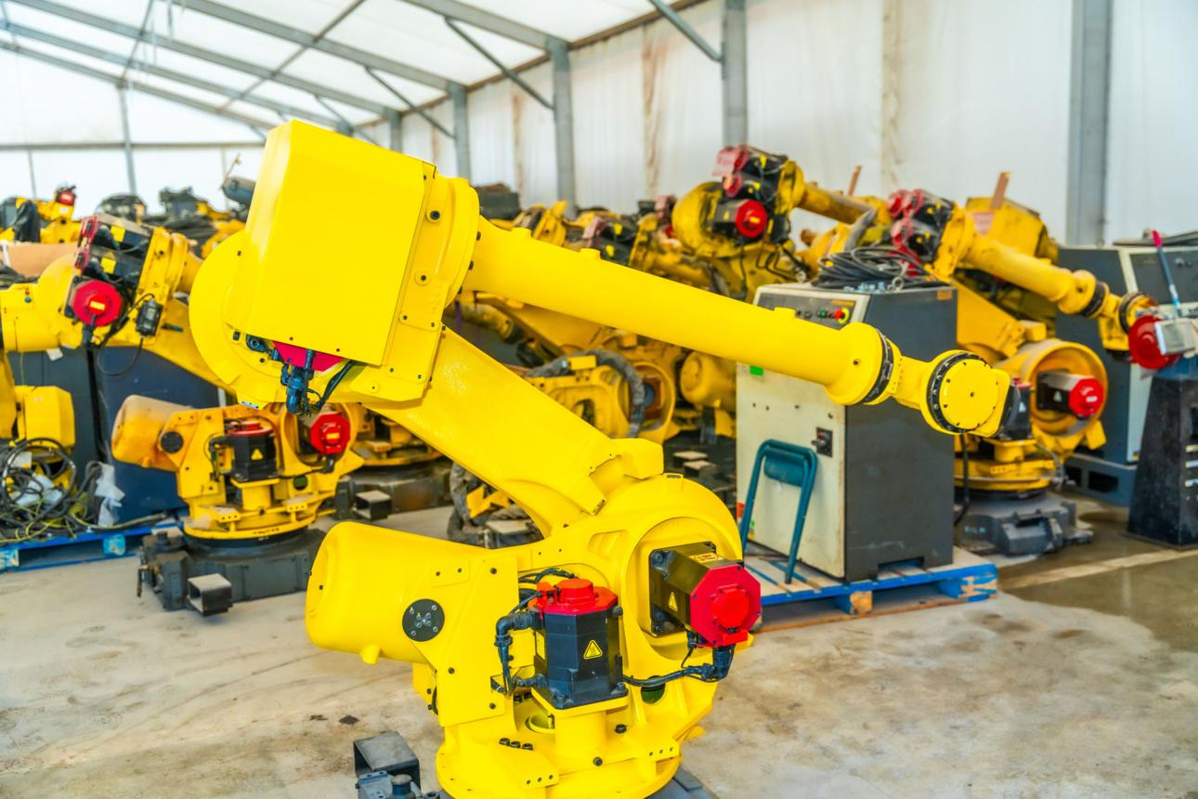
7
🔹 1. Speed
- Perform calculations and tasks very fast (seconds or less)
🔹 2. Accuracy
- High level of precision if instructions are correct
🔹 3. Storage
- Can store huge amounts of data (files, videos, databases)
🔹 4. Automation
- Perform repetitive tasks automatically without fatigue
🔹 5. Communication
- Enable fast communication (email, messaging, video calls)
🔹 6. Multitasking
- Run multiple applications at the same time

❌ Disadvantages of Computers

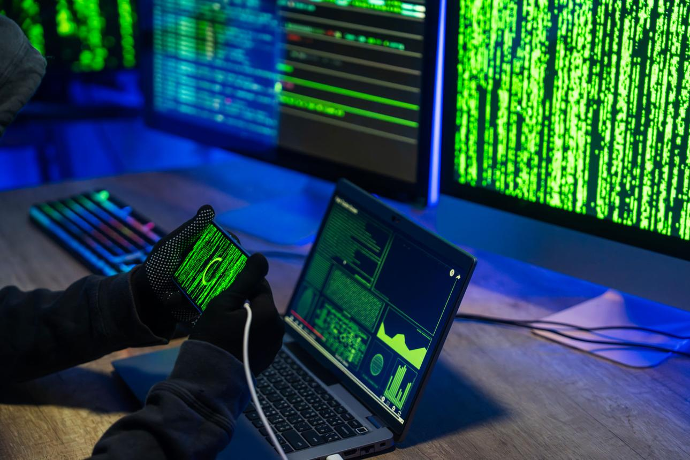

6
🔹 1. Health Issues
- Eye strain, back pain, lack of physical activity
🔹 2. Security Risks
- Hacking, viruses, data theft
🔹 3. Job Loss
- Automation can replace some human jobs
🔹 4. Addiction / Overuse
- Excessive use of games, social media
🔹 5. Dependence
- People rely too much on computers
🔹 6. Cost
- Buying and maintaining computers can be expensive

⚖️ Final thought
Computers are very powerful tools, but their impact depends on how we use them.

🧾 One-line summary
Computers offer speed, accuracy, and efficiency, but can also cause health, security, and social problems if misused.

Booting
# Source: AI Source: Provided by: [Data Path: Persons Table -> ID Column: 1, Name_En Column: Motasem Essam] -> From: [ChatGPT] on [4/22/2026]
Starting the Computer (also called booting) is the process of turning on a computer and loading the operating system so it becomes ready to use.

🔹 What is Booting?
# Source: AI Source: Provided by: [Data Path: Persons Table -> ID Column: 1, Name_En Column: Motasem Essam] -> From: [ChatGPT] on [4/22/2026]
Booting is when the computer:
- Powers on
- Checks its hardware
- Loads the operating system (like Windows or Linux)

🔄 Booting process (simple steps)
# Source: AI Source: Provided by: [Data Path: Persons Table -> ID Column: 1, Name_En Column: Motasem Essam] -> From: [ChatGPT] on [4/22/2026]
Power On -> POST (Hardware Check) -> Load Operating System -> Ready to Use

⚙️ Step-by-step explanation
# Source: AI Source: Provided by: [Data Path: Persons Table -> ID Column: 1, Name_En Column: Motasem Essam] -> From: [ChatGPT] on [4/22/2026]
1. Power On
- Press the power button
- Electricity starts flowing to the system
2. POST (Power-On Self Test)
- The computer checks hardware (RAM, keyboard, etc.)
- If there’s a problem, it may show an error
3. Loading the Operating System
- The system loads the OS from storage (HDD/SSD) into memory
4. Login / Desktop Screen
- The computer is ready to use

🔹 Types of Booting
# Source: AI Source: Provided by: [Data Path: Persons Table -> ID Column: 1, Name_En Column: Motasem Essam] -> From: [ChatGPT] on [4/22/2026]
🔸 Cold Boot (Hard Boot)
- Starting the computer from off state
- Example: turning on your PC in the morning
🔸 Warm Boot (Soft Boot)
- Restarting the computer without turning it off completely
- Example: clicking “Restart”

🖥️ Example
# Source: AI Source: Provided by: [Data Path: Persons Table -> ID Column: 1, Name_En Column: Motasem Essam] -> From: [ChatGPT] on [4/22/2026]
- Press power button
- See logo screen
- OS loads
- Desktop appears → ready to work

Starting the computer
# Source: Academic source: Provided by: [Data Path: Persons Table -> ID Column: 1, Name_En Column: Motasem Essam] -> From: [Data Path: Sources Table -> ID Column: 158, Content Title Column: Academic Source - Modern academy - 2017-2018 - Intro to Computer Science - Computer systems] -> at: [Document, page: 14, all, “Image - Tool: [Lightshot Program]”] on [4/22/2026]
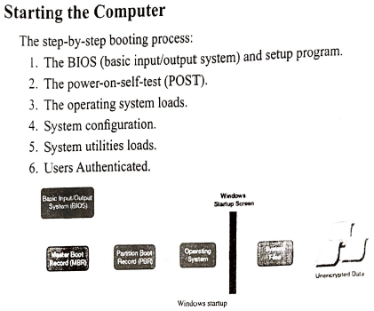
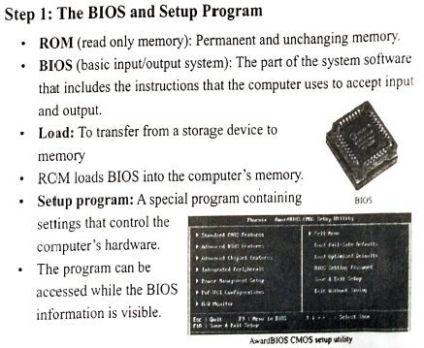

# Source: Academic source: Provided by: [Data Path: Persons Table -> ID Column: 1, Name_En Column: Motasem Essam] -> From: [Data Path: Sources Table -> ID Column: 158, Content Title Column: Academic Source - Modern academy - 2017-2018 - Intro to Computer Science - Computer systems] -> at: [Document, page: 15, all, “Image - Tool: [Lightshot Program]”] on [4/22/2026]
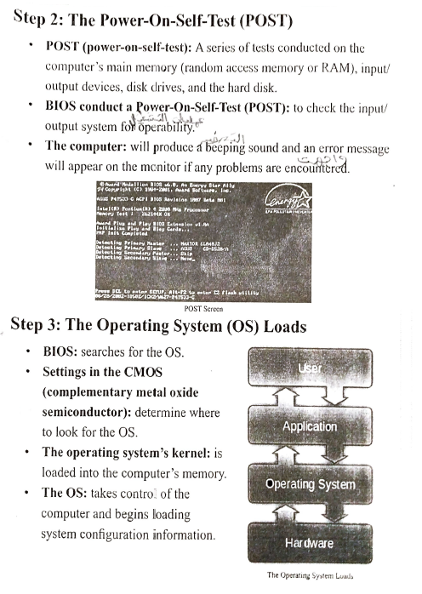

# Source: Academic source: Provided by: [Data Path: Persons Table -> ID Column: 1, Name_En Column: Motasem Essam] -> From: [Data Path: Sources Table -> ID Column: 158, Content Title Column: Academic Source - Modern academy - 2017-2018 - Intro to Computer Science - Computer systems] -> at: [Document, page: 16, all, “Image - Tool: [Lightshot Program]”] on [4/22/2026]
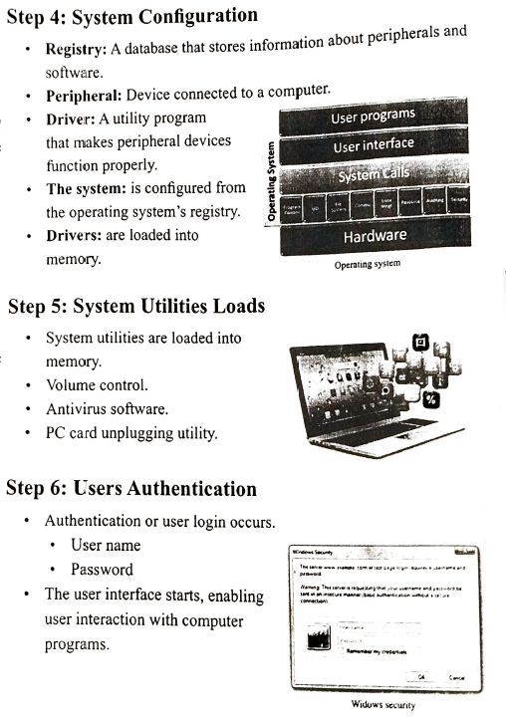

🧾 One-line definition
# Source: AI Source: Provided by: [Data Path: Persons Table -> ID Column: 1, Name_En Column: Motasem Essam] -> From: [ChatGPT] on [4/22/2026]
Starting a computer is the process of turning it on and loading the operating system to make it ready for use.

🌍 One-line definition
# Source: AI Source: Provided by: [Data Path: Persons Table -> ID Column: 1, Name_En Column: Motasem Essam] -> From: [ChatGPT] on [4/22/2026]
A computer is a machine that processes data using instructions (software) to produce meaningful results (information).

